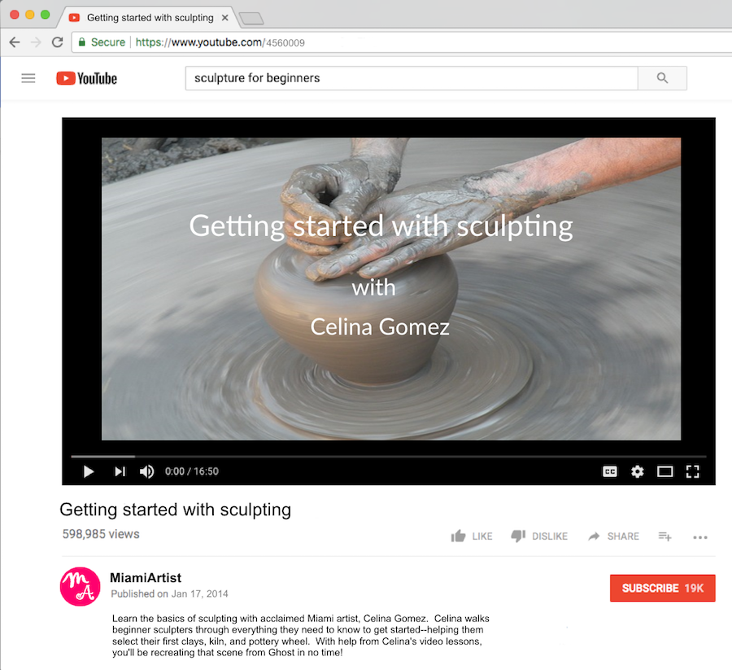

Learn the basics of sculpting with acclaimed Miami artist, Celina Gomez. Celina walks beginner sculptors through everything they need to know to get started—helping them select their first clays, kiln, and pottery wheel! You’ll be sculpting in no time, with help from Celina’s video lessons!